Agenda- To change operator time zone

To achieve this we need to have one section rule one activity rule and one decision table

So we created a section rule

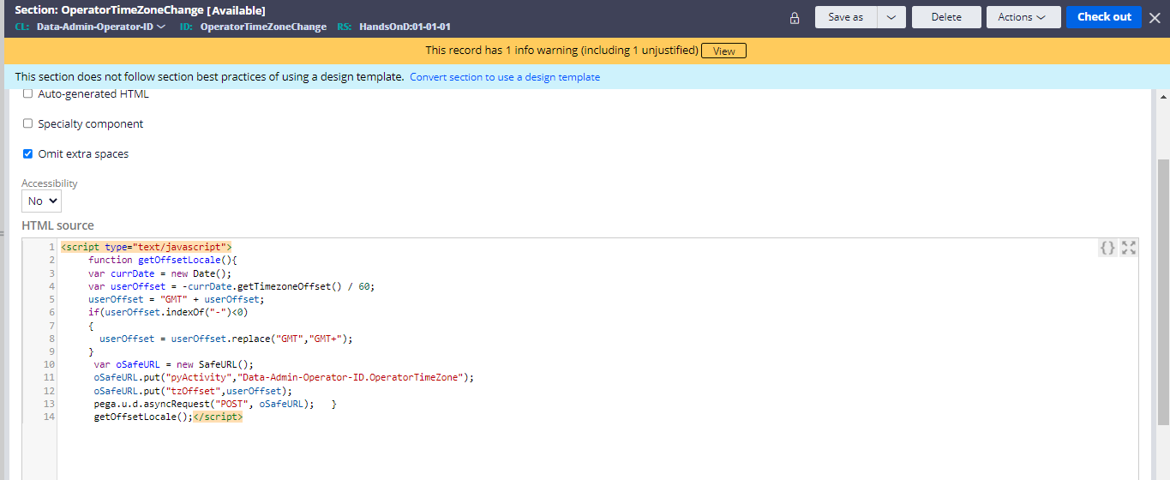

So in the code wat we did is

<script type="text/javascript">

     function getOffsetLocale(){

     var currDate = new Date();

     var userOffset = -currDate.getTimezoneOffset() / 60;

     userOffset = "GMT" + userOffset;

     if(userOffset.indexOf("-")<0)

     {

       userOffset = userOffset.replace("GMT","GMT+");

     }

      var oSafeURL = new SafeURL();

      oSafeURL.put("pyActivity","Data-Admin-Operator-ID.OperatorTimeZone");

      oSafeURL.put("tzOffset",userOffset);

      pega.u.d.asyncRequest("POST", oSafeURL);   }

      getOffsetLocale();</script>

  var userOffset = -currDate.getTimezoneOffset() / 60;

here the timezone is being calculated divided by 60 seconds and also we are passing an activity

and in the code below

      oSafeURL.put("pyActivity","Data-Admin-Operator-ID.OperatorTimeZone");

we are passing the activity OperatorTimeZone activity

so the activity is configured as below

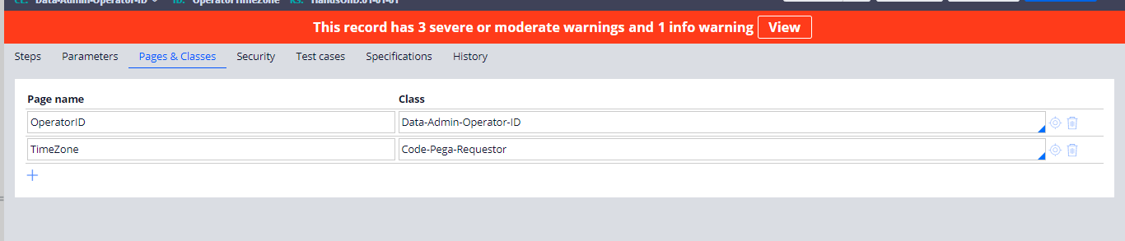

And in the class and page we are using this code and inside the steps 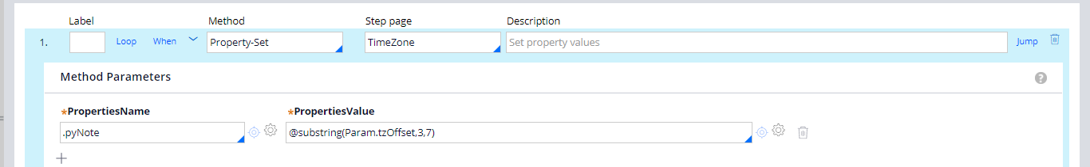

And inside that we are assigning the substring where we are passing the timezone which we want to get after the GMT

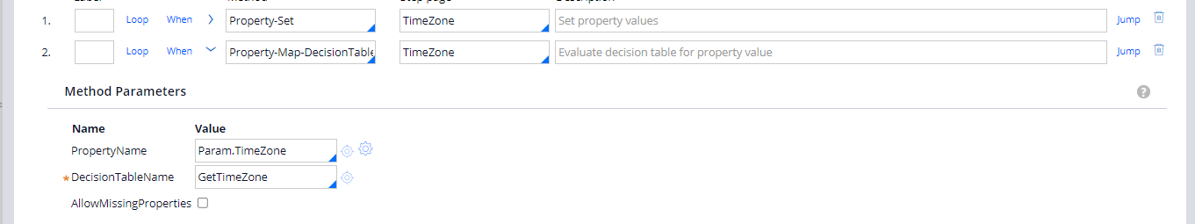

And In that we are mapping the Decision table in which we are defining different country timezones

And in the 3rd step of the activity we are using to map the defaulttimezone to the operator timezone

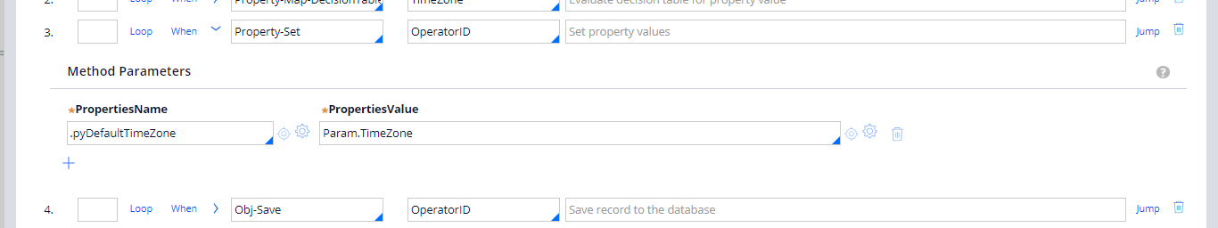

And after that use Obj-Save with write- now to see the changes

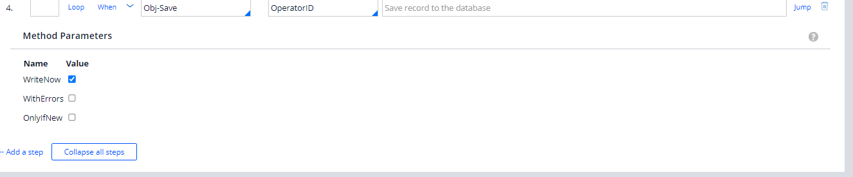

And this we are passing our activity inside the code

     oSafeURL.put("pyActivity","Data-Admin-Operator-ID.OperatorTimeZone");

and we have the decision table configured as below

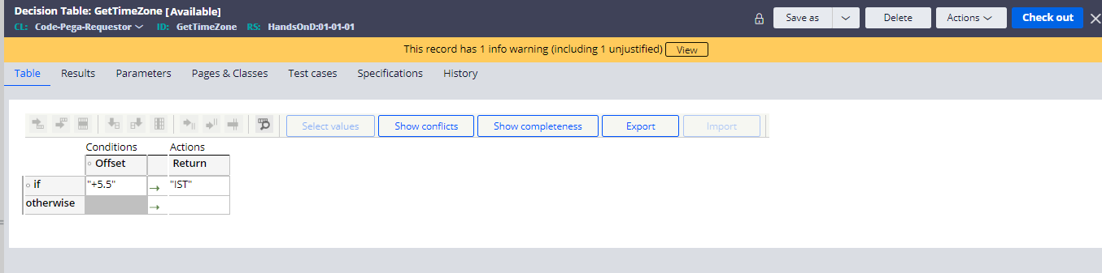

So we are assigning the offset and have the substring and get the time so that we are assigning an action as what to get when the Activity runs

and now save all the rules and run the section to change the timezone.

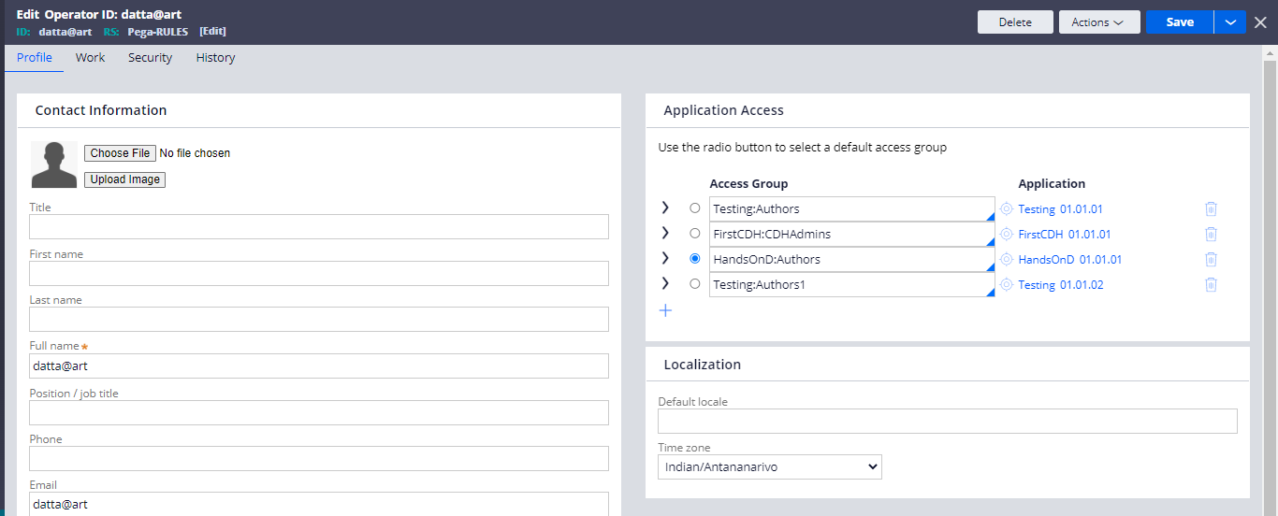

Now after the time now run the section and run it

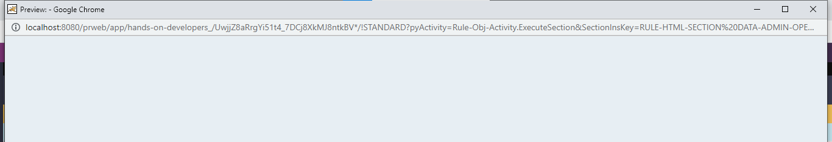

And now it is changed

